User Manual

Version 1.0

Author: Michael Persaud

# 1.0. Introduction

## 1.1. Purpose

The purpose of this software is to extract useful data on media from webpages namely Amazon.com and store it for useful querying and evaluation of media in an inventory

## 1.2. Scope of Project

This project gains information on books through the use of ISBN and Amazon.com which pulls Title,Author, Publisher, Year Published, Price(Currently), Quantity, Rating, and Icon of book.

# 2.0. Overall Description

## 2.1 System Environment

The software is ran through one main class called driver which handles which form the software is ran. There is also a Bookitem class to store the item, Storage class to hold items per ISBN for easy lookup, GUI class to handle all GUI functions and URLProccessor class which handles parsing and obtaining data.

## 2.3 User Characteristics

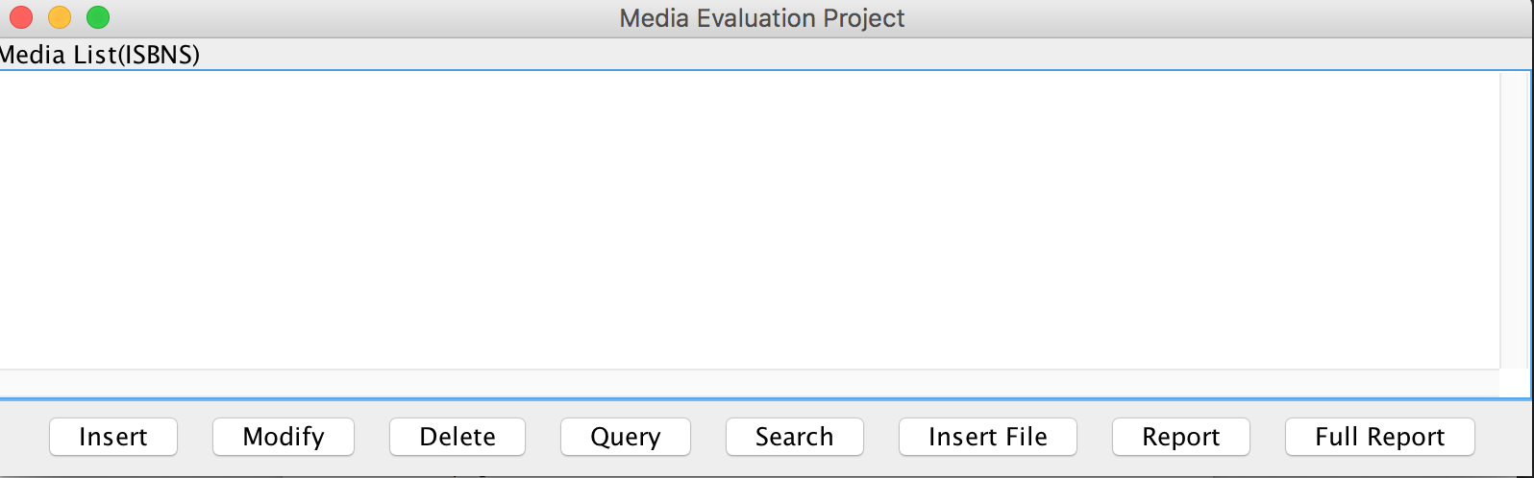

If a user loads the GUI interface, This is what they see. They can individually add, modify ,or delete entries in the database. Also they can query through ISBN and search on the web with the ISBN. Report provides a report on the last searched ISBN, and Full Report makes a report of all entries in Database.

3.0. Requirements Specification

## 3.1 External Interface Requirements

The software can be run from command line inputting two parameters, a list of ISBNS and a file to output to , The output file is in a delimited format which can be used as a spreadsheet or spreadsheet program.

4.0. Bugs

This software does not always provide the correct data. It is worthwhile to look through the data through Query and modify what does not seem right. Examples is price as null or rating being more than 5 stars.